Project

1. Commerce Website

**Table Of Contents**

1. **Introduction**  3
   1. Setup Checklist for Project 3
2. **Problem Statement** 4
   1. Objective 4
   2. Technologies Used 4
3. **Implementation in React**  9

3.1 Summary of the functionality to be built 9

**INTRODUCTION:**

The document outlines a project for the React. The project is to create e-commerce website. This document contains the work flow of the system and gives guidelines of how to build the functionality gradually in each of the course modules of the react.

* 1. **SETUP CHECK LIST FOR PROJECT**

**Minimum System Requirements**

* Intel Pentium 90 or higher
* Microsoft windows 2010 or above
* Memory: 8GB or RAM
* Internet Explorer 10 or higher
* Visual Studio

**2. PROBLEM STATEMENT**

**2.1 OBJECTIVE**

E-commerce business drives profitable growth with reduction is cost-to-customer, developing customer-reach, and providing a unique customer experience. It has become more essential for businesses to make the right use of e-commerce. Now, e-commerce is evolving or better say evolved into digital commerce that implies to the entire business journey from buying to delivery with an online experience. Below are the few objectives of e-commerce:

**2.2 TECHNOLOGIES USED**

What Does Web Mean?

The Web is the common name for the World Wide Web, a subset of the Internet consisting of the pages that can be accessed by a Web browser. Many people assume that the Web is the same as the Internet, and use these terms interchangeably. However, the term Internet actually refers to the global network of servers that makes the information sharing that happens over the Web possible. So, although the Web does make up a large portion of the Internet, but they are not one and same.

# **E-commerce:**

E-commerce (electronic commerce) is the buying and selling of goods and services, or the transmitting of funds or data, over an electronic network, primarily the internet. These business transactions occur either as business-to-business ([B2B](https://searchcio.techtarget.com/definition/B2B)), business-to-consumer ([B2C](https://searchcustomerexperience.techtarget.com/definition/B2C)), consumer-to-consumer or consumer-to-business.

Commerce.js is a e-commerce website witch developed using following technologies-

## HTML

**HTML** (Hyper Text Markup Language) is the most basic building block of the Web. It defines the meaning and structure of web content. Other technologies besides HTML are generally used to describe a web page's appearance/presentation ([CSS](https://developer.mozilla.org/en-US/docs/Web/CSS)) or functionality/behavior ([JavaScript](https://developer.mozilla.org/en-US/docs/Web/JavaScript)).

"Hypertext" refers to links that connect web pages to one another, either within a single website or between websites. Links are a fundamental aspect of the Web. By uploading content to the Internet and linking it to pages created by other people, you become an active participant in the World Wide Web.

**CSS**

**CSS** (Cascading Style Sheets) is a declarative language that controls how web pages look in the [browser](https://developer.mozilla.org/en-US/docs/Glossary/Browser). The browser applies CSS style declarations to selected elements to display them properly. A style declaration contains the properties and their values, which determine how a webpage looks.CSS is one of the three core Web technologies, along with [HTML](https://developer.mozilla.org/en-US/docs/Glossary/HTML) and [JavaScript](https://developer.mozilla.org/en-US/docs/Glossary/JavaScript). CSS usually styles [HTML elements](https://developer.mozilla.org/en-US/docs/Glossary/Element), but can be also used with other markup languages like [SVG](https://developer.mozilla.org/en-US/docs/Glossary/SVG) or [XML](https://developer.mozilla.org/en-US/docs/Glossary/XML).A CSS rule is a set of [properties](https://developer.mozilla.org/en-US/docs/Glossary/property/CSS) associated with a [selector](https://developer.mozilla.org/en-US/docs/Glossary/CSS_Selector). Here is an example that makes every HTML paragraph yellow against a black background:

**Bootstrap**

Bootstrap is a free, open source [HTML](https://developer.mozilla.org/en-US/docs/Glossary/HTML), CSS, and [JavaScript](https://developer.mozilla.org/en-US/docs/Glossary/JavaScript) framework for quickly building responsive websites.

Initially, Bootstrap was called Twitter Blueprint and was developed by a team working at [Twitter](https://twitter.com/). It supports responsive design and features predefined design templates that you can use out of the box, or customize for your needs with your code. You don't need to worry about compatibility with other browsers either, as Bootstrap is compatible with all modern browsers and newer versions of [Internet Explorer](https://developer.mozilla.org/en-US/docs/Glossary/Microsoft_Internet_Explorer).

**JS**

**JavaScript** (**JS**) is a lightweight, interpreted, or [just-in-time](https://en.wikipedia.org/wiki/Just-in-time_compilation) compiled programming language with [first-class functions](https://developer.mozilla.org/en-US/docs/Glossary/First-class_Function). While it is most well-known as the scripting language for Web pages, [many non-browser environments](https://en.wikipedia.org/wiki/JavaScript#Other_usage) also use it, such as [Node.js](https://developer.mozilla.org/en-US/docs/Glossary/Node.js), [Apache CouchDB](https://couchdb.apache.org/) and [Adobe Acrobat](https://www.adobe.com/devnet/acrobat/javascript.html). JavaScript is a [prototype-based](https://developer.mozilla.org/en-US/docs/Glossary/Prototype-based_programming), multi-paradigm, single-threaded, dynamic language, supporting object-oriented, imperative, and declarative (e.g. functional programming) styles.

**Reactjs**

ReactJS is JavaScript library used for building reusable UI components. According to React official documentation, following is the definition −

React is a library for building composable user interfaces. It encourages the creation of reusable UI components, which present data that changes over time. Lots of people use React as the V in MVC. React abstracts away the DOM from you, offering a simpler programming model and better performance. React can also render on the server using Node, and it can power native apps using React Native. React implements one-way reactive data flow, which reduces the boilerplate and is easier to reason about than traditional data binding.

**Nodejs**

A Node.js app runs in a single process, without creating a new thread for every request. Node.js provides a set of asynchronous I/O primitives in its standard library that prevent JavaScript code from blocking and generally, libraries in Node.js are written using non-blocking paradigms, making blocking behavior the exception rather than the norm.

**MongoDB**

**MongoDB**, the most popular NoSQL database, is an open-source document-oriented database. The term ‘NoSQL’ means ‘non-relational’. It means that MongoDB isn’t based on the table-like relational database structure but provides an altogether different mechanism for storage and retrieval of data. This format of storage is called BSON ( similar to JSON format).

**Description:**

Any member can register and view available products.

Only registered member can purchase multiple products regardless of quantity.

Contact Us page is available to contact Admin for queries.

There are three roles available: Visitor, User and Admin.

Visitor can view available products.

User can view and purchase products.

An Admin has some extra privilege including all privilege of visitor and user.

Admin can add products, edit product information and add/remove product.

Admin can add user, edit user information and can remove user.

Admin can ship order to user based on order placed by sending confirmation mail.

**System Design**

Design The system is divided into some parts these are Register system, Login System, Search System, Buying System, Order Received System, Viewing System side with database represent the server using PHP MYSQL and APACHE with XAMPP server.

User Characteristics Admin The administrator has all the rights to access the system. He is the one who has all rights to view the members and product details, modify those details. He can add various product based on the category. He can also set the available quantity of a product and its reasonable price. Also he can also set discount in various occasion.

Users: The user can log in to the system by using his specific email and password. User can view the products and order the products according to their own needs. He can view his profile and update his details. He can update his personal information by logging into the system. User can find various product by using search option easily. update his details. He can update his personal information by logging into the system

System Information This system is an automated Shop Management System. Through the software user can add members, add product, search product, update information, edit information, buy the product in quick time.

Technical Feasibility It is technically feasible, since there will not be much difficulty in getting required resources for the development and maintaining the system as well. All the resources needed for the development of the software as well as the maintenance.

**Implementing Tools for the Project**

HTML , CSS , Bootstrap , MySQL , XAMPP

It is a simple, lightweight Apache distribution that makes it extremely easy for developers to create a local web server for testing purposes. Everything you need to set up a web server – server application (Apache), database (MySQL), and scripting language (PHP) – is included in a simple extractable file. XAMPP is also cross-platform, which means it works equally well on Linux, Mac and Windows. Since most actual web server deployments use the same components as XAMPP, it makes transitioning from a local test server to a live server is extremely easy as well. Web development using XAMPP is especially beginner friendly.

1. **IMPLEMENTATION IN REACT:**

SUMMARY OF THE FUNCTIONALITY TO BE BUILT:

Here, we developed a e-commerce website where we built functionalities like add to cart, remove, empty cart, checkout and in which we have shipping address and payment details.

Add to cart: Here, we can add the items we want to buy .

Remove:Here, we can increase or decrease the items from cart.

Empty cart:Here, we can empty the items from cart.

Checkout:Here ,we go for giving address for shipping and then make final payment.

**Website View:**

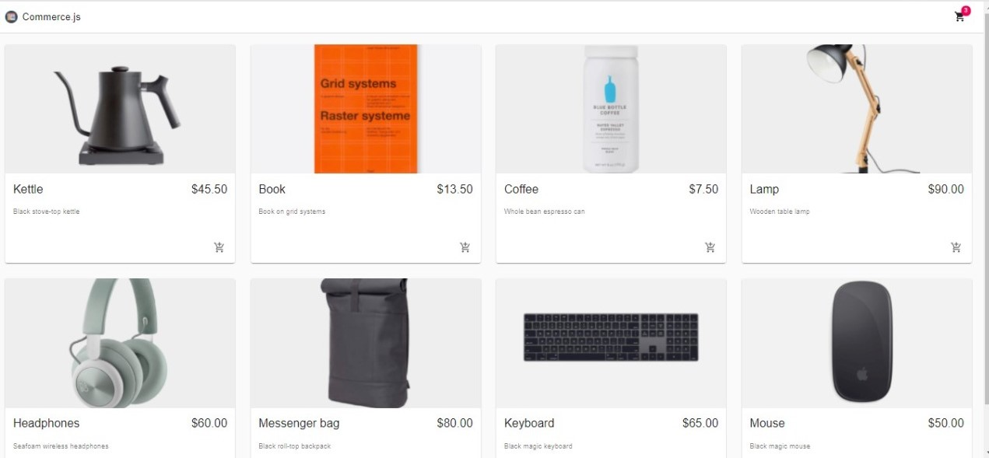

**Add to cart:**

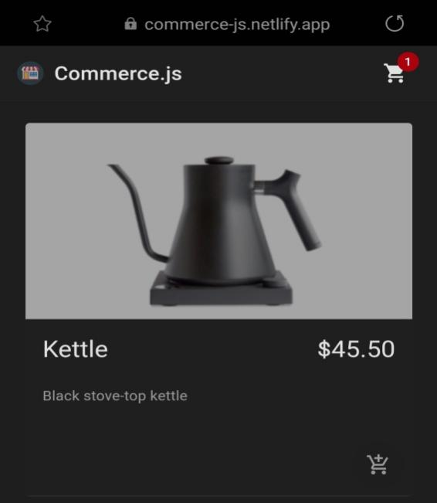

If we will remove item then:

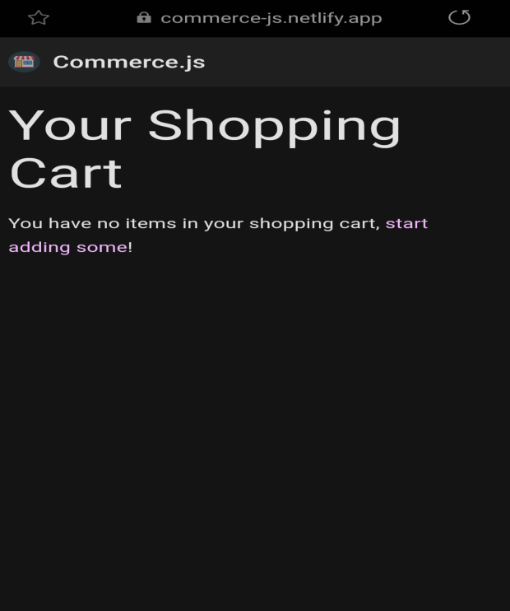

**Checkout:**

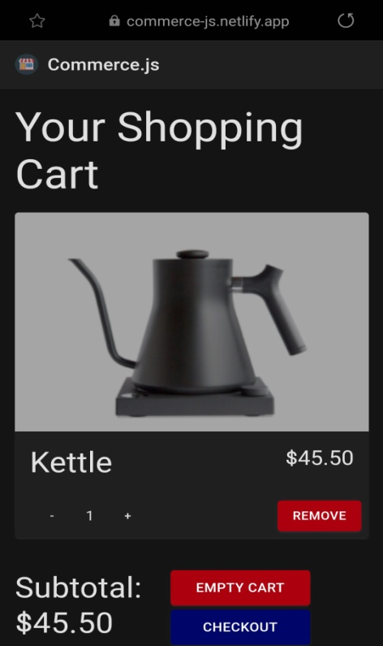

**Shipping address:**

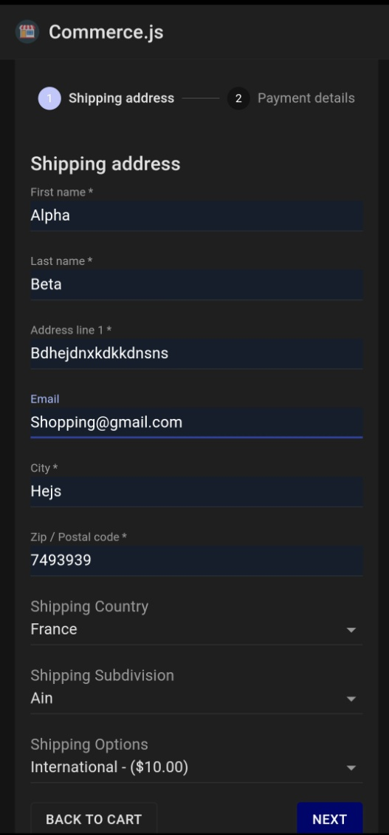

**Payment details:**

